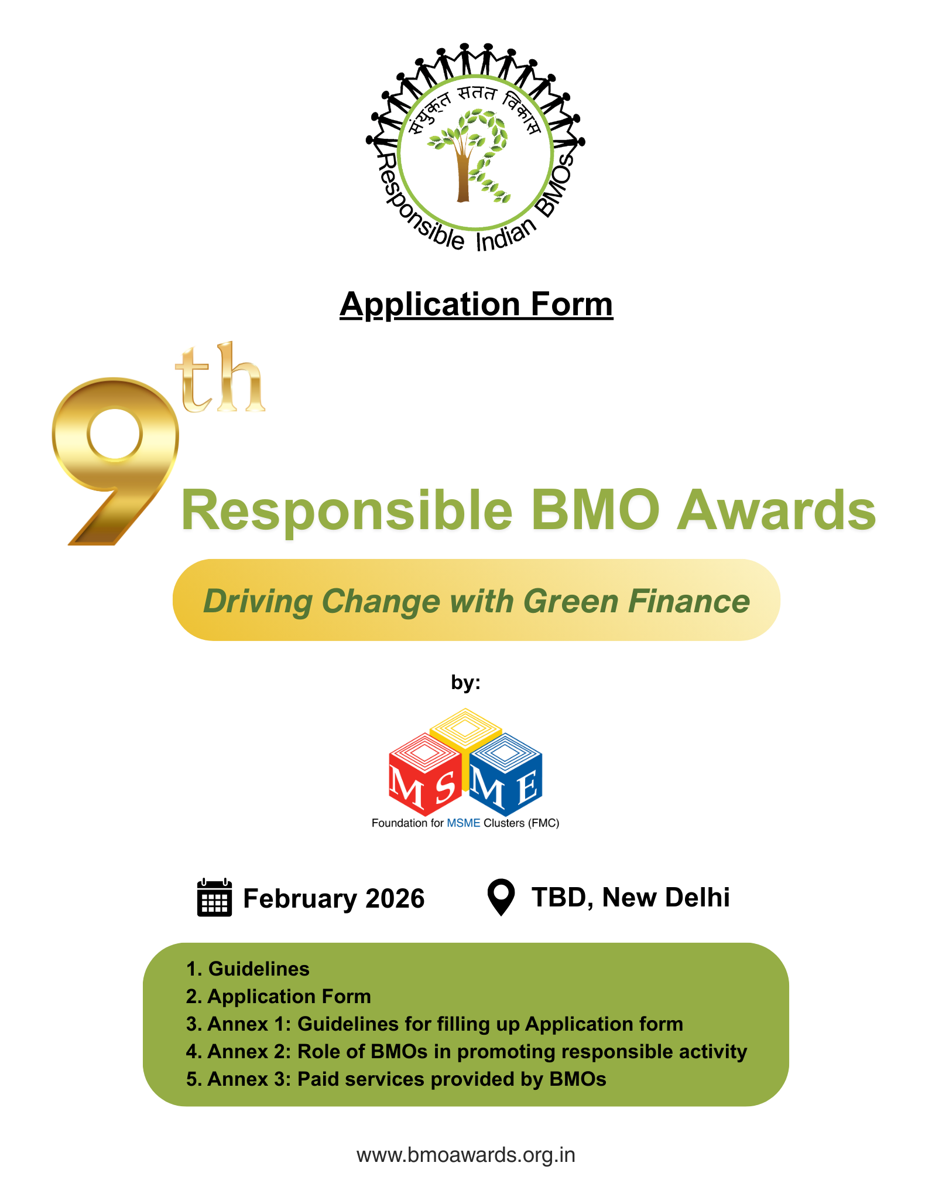

1. **Instructions for Filling up Application Form**
   1. **Thematic Area:** Like every year, the 2024–25 Responsible BMO Awards will recognize MSME BMOs that have demonstrated commendable initiatives in the fields of innovation, social impact and environmental responsibility.

The ninth edition of responsible BMO Award takes a significant leap forward by introducing the theme of Green Financing. Aligned with India’s climate and development goals, this year’s event will spotlight the role of BMOs in enabling MSMEs’ access to green finance for cleaner technologies, resource efficiency, renewable energy and climate-resilient practices, strengthening both competitiveness and long-term resilience.

* 1. **Basic Instructions**

1. Kindly type/handwrite legibly.
2. Please give all details of District, State, Pin Code, etc. of your address.
3. All achievements (completed and ongoing) should be only for the period specified in the application form i.e. **1stApril 2022 to 31st March 2024**. The exact time period is appropriately mentioned, wherever required in this form.
4. In case a BMO sends more than one application form, the application form that reaches us first (electronically or by post), will be considered for the Award.
5. FMC will not be responsible for application forms received after the deadline.
6. Decision of the jury will be final in all cases.
   1. **Whom to Apply**
7. 1 copy of completed application form (in English/Hindi) is to be submitted either by mail at [**bmoawards@msmefoundation.org**](mailto:bmoawards@msmefoundation.org)(soft copy) or by post (hard copy) in a **SEALED ENVELOPE** to **Mr. Rahul Nath**, Foundation for MSME Clusters, USO House, USO Road, Off Shaheed Jeet Singh Marg, New Delhi-110067, India (Tel: 011-40563323/24).
8. For any query, please contact

Name: Ms. Megha Rawat

Email Id: [megha@msmefoundation.org](mailto:megha@msmefoundation.org)

Mob No: 8369246227

* 1. **Eligibility Criterion for Application**

1. This award is for BMOs based in India. BMOs mostly have individual entrepreneurs, firms, other BMOs, non-industry invitees, etc. as members, to whom they provide a variety of business development services (BDS) with the primary aim of enhancing their competitiveness.
2. A BMO can be registered as a Society or a Trust or a Co-operative Society or a Section 8 (earlier Section 25)/Producers Company, etc. in India. An informal (non-registered) BMO operating in India, can also apply.
3. Chief Executive Officer or President or Chairperson or a person with equivalent designation of a BMO should not be a government official.
4. In case of any doubt with respect to the status of a BMO who has applied for the Award and for the award category for which the BMO has applied for, FMC can ask for further information to clarify the status.
   1. **Eligibility Criteria for Award Winning Activity**
5. The Award is given for a Responsible Activity
6. For definition of Responsible Activity, please see Annex 2.
7. The responsible activity (see point 2.9) you have proposed for the Award must happen/continue to happen and give results during **1stApril 2024 to 31st March 2025**. However, if the BMO has initiated an Activity prior to 1stApril 2024, but continue to do the same during any time period within 1stApril 2024 to 31st March 2025, the same will be considered for the Award. An activity that started before 1st April 2024 and got completed before 1stApril 2025, will be considered ineligible for the purpose of this Award. **If the activity completed before 1st April 2024, it will not be considered.**
8. The Award-winning BMOs and Special Jury Awardees in the previous seven “Responsible Indian BMOs” Awards, are not eligible to apply for the same Responsible Activity for which they had already been awarded.
9. **Application Form**

**IMPORTANT**: Kindly read the Guidelines carefully while filling up the Application Form. Incomplete Application Form is liable to be rejected or be evaluated accordingly. The Guidelines appear in Section I as well as in Annex 1, 2 and 3. Kindly do not change any entry parameter. Doing so may lead to disqualification by the Jury / Assessors.

* 1. **Full Name of BMO**

|  |  |  |  |  |  |  |  |  |  |  |  |  |  |  |  |  |  |  |  |  |  |
| --- | --- | --- | --- | --- | --- | --- | --- | --- | --- | --- | --- | --- | --- | --- | --- | --- | --- | --- | --- | --- | --- |
|  |  |  |  |  |  |  |  |  |  |  |  |  |  |  |  |  |  |  |  |  |  |
|  |  |  |  |  |  |  |  |  |  |  |  |  |  |  |  |  |  |  |  |  |  |
|  |  |  |  |  |  |  |  |  |  |  |  |  |  |  |  |  |  |  |  |  |  |

* 1. **Communication Details of BMO**

|  |  |  |  |  |  |  |  |  |  |  |  |  |  |  |  |  |  |  |  |  |  |
| --- | --- | --- | --- | --- | --- | --- | --- | --- | --- | --- | --- | --- | --- | --- | --- | --- | --- | --- | --- | --- | --- |
| 2.2.1 Address | | | | | | | | | | | | | | | | | | | | | |
|  |  |  |  |  |  |  |  |  |  |  |  |  |  |  |  |  |  |  |  |  |  |
|  |  |  |  |  |  |  |  |  |  |  |  |  |  |  |  |  |  |  |  |  |  |
| City/Town/Village | | | | |  |  |  |  |  |  |  |  |  |  |  |  |  |  |  |  |  |
| District | | | | |  |  |  |  |  |  |  |  |  |  |  |  |  |  |  |  |  |
| State | | | | |  |  |  |  |  |  |  |  |  |  |  |  |  |  |  |  |  |
| PIN | | | | |  |  |  |  |  |  |  |  |  |  |  |  |  |  |  |  |  |
| 2.2.2 Email Id | | | | |  | | | | | | | | | | | | | | | | |
| 2.2.3 Website | | | | |  | | | | | | | | | | | | | | | | |
| 2.2.4 Was the website developed before March 31, 2025? | | | | | Yes/No (please tick) | | | | | | | | | | | | | | | | |
| 2.2.5 Is the website active? Yes/No | | | | |  | | | | | | | | | | | | | | | | |
| 2.2.6 Contact Details of Nodal Person | | | | | Name:  Email:  Mobile: | | | | | | | | | | | | | | | | |

(Note: Activity of the website will be confirmed during evaluation of the Application Form)

**2.3 (a) Type of BMO (please** ✓**mark)**

(Please see item 1.2 in Annex 1 for further clarification)

1. Special Purpose Vehicle (SPV) Level 🞎
2. Industrial Area (IA) / Industrial Estate (IE) Level 🞎
3. Cluster Level 🞎
4. District Level 🞎
5. State Level 🞎
6. Country Level 🞎
   1. **(b) Total numbers of members**__________________

**2.3 (c) Of which**, Large_______, Medium _______, Small _________, Micro __________.

**2.3 (d) Non-MSME Members___________**

(Note: As per definitions of large, medium, small and micro: see Annex Section 1.4)

**2.4 Registration details of the BMO**

1. Registered as (tick whatever is applicable)

Society / Trust / Cooperative Society / Company / Section 8 Company (2013 Act)/ Section 25 Company (1956 Act)/ Producer’s Company / Any other (please specify)

.......................................................

1. Did the BMO have an office as on March 31, 2025? Yes 🞎 No 🞎  
   (please tick whatever is applicable)

If yes,

1. Office on rented/leased premises Yes 🞎 No 🞎
2. Office owned by BMO Yes 🞎 No 🞎
3. Did the BMO have full time paid employees/consultant as on March 31st, 2025 (please tick)

Yes 🞎 No 🞎

If yes, mention the number of full-time paid employees/consultant the BMO had as on March 31st, 2025……………………

1. Did the BMO have Membership Fee/Equity based members as on March 31st, 2025 (please tick)

Yes 🞎 No 🞎

1. Year of Establishment___________________
   1. **Has the BMO received/awarded any of the following quality accreditations on or before March 31, 2025 and the certificate is still valid? (Please tick)**
2. BMO Accreditation from NABET-QCI Yes 🞎 No 🞎
3. National/international quality certification (e.g. ISO certification) Yes 🞎 No 🞎
4. Any other form of accreditation / certification Yes 🞎 No 🞎

If yes, please specify ……………………………………………………………

**\*Note: If you choose yes, for 2.5(a) / 2.5(b) / 2.5(c), attaching a copy of valid accreditation / certificate is mandatory for consideration of this information for the Award.**

**2.6** **Please mention five Responsible Activities implemented by your BMO during the period 1stApril 2022 – 31st March 2025 for promoting RESPONSIBLE BUSINESS (e.g. Green Financing).**

|  |  |  |  |  |
| --- | --- | --- | --- | --- |
|  | **Name of the Activity** | **Year/s done**  **(Please tick)** | | |
| **1st April 2022 -**  **31st March**  **2023** | **1st April 2023 - 31st March 2024** | **1st April 2024 - 31st March 2025** |
|  |  |  |  |  |
|  |  |  |  |  |
|  |  |  |  |  |
|  |  |  |  |  |
|  |  |  |  |  |

\***Note:**(a) Suggestive nature of activities appear in Annex 2

(b) If an activity is done in multiple years, you can tick boxes for multiple years

(c) Only one of these activities should preferably be detailed in point 2.9 below

* 1. **Please mention five paid services provided by BMO to their members/ non-members during 1stApril 2022 – 31st March 2025.**

|  |  |  |  |  |  |  |
| --- | --- | --- | --- | --- | --- | --- |
|  | **Name of service** | **Was part/full expense covered through fees from participants for the activity (Please tick)** | | **Year of the service**  **(Please tick)** | | |
| **Yes** | **No** | **1st April 2022 -**  **31st March**  **2023** | **1st April 2023 - 31st March 2024** | **1st April 2024 - 31st March 2025** |
|  |  |  |  |  |  |  |
|  |  |  |  |  |  |  |
|  |  |  |  |  |  |  |
|  |  |  |  |  |  |  |
|  |  |  |  |  |  |  |

\***Note:** Paid service is one where part/full expense was charged from participants of the activity as a participation fee. Please refer to Annex 3 for suggestive types of paid services. A responsible activity can also be a paid service and if so, can appear in this table too.

* 1. (a) Please mention at most 3 Schemes of Union /State/ Union Territory Government of India availed by BMO during the period **1st April 2022 – 31st March 2025**

1. ______________________________________________________
2. ______________________________________________________
3. ______________________________________________________

(b) Please mention 3 programmes/support availed from nationals/internationals organisations/companies by BMO during the period **1st April 2022 – 31st March 2025**

1. ______________________________________________________
2. ______________________________________________________
3. ______________________________________________________
   1. **Please answer the following questions on the “Responsible Activity” provided by your BMO to be considered for Award. Selecting an activity from point 2.6 above is preferred.** (Please see item 1.3 in Annex 1 for guidance)
4. Name of the activity

............................................................................................................................................

………………………………………………………………………………………………………

b.1 Type of activity (Please tick any one box)

Environmental 🞎

Social 🞎

(Please refer to Annex 2 for guidance)

b.2 Did this activity receive any award in any of the previous BMO Award of FMC (please tick)

Yes 🞎 No 🞎

1. Nature of the activity, Please, tick any one of the following
2. Advocacy 🞎
3. Workshop/Seminar/Camp/Exposure Visit 🞎
4. Training 🞎
5. Services 🞎
6. Infrastructure 🞎
7. Any other, please detail

………………………………………………………………………………………………………………………………………………………………………………………………

1. Is the activity done (Please tick any one box)
2. Continuously throughout 2024-25 🞎
3. More than - twice a year/two months in 2024-25 🞎
4. More than – once a year/one month in 2024-25 🞎
5. Once in 2024-25 🞎
6. None of the above 🞎
7. When did this activity start its operation? (please mention the month and year)

.............................................................................................................................................

1. Was the activity getting implemented during the year 2024-25 yes 🞎 No 🞎
2. How did the activity help members of BMO? (25 words)

.............................................................................................................................................

.............................................................................................................................................

.......................................................................................................................................................................................................................................................................................................................................................................................................................................

1. Did the activity help the non-members of the BMO? Yes 🞎 No🞎

If yes, how? Who are these non-members? (25 words)

.............................................................................................................................................

.............................................................................................................................................

.............................................................................................................................................

1. Did the activity help the local community? Yes 🞎 No🞎

If yes, how? Who are these non-members/local community?

.............................................................................................................................................

.............................................................................................................................................

.............................................................................................................................................

1. Do you consider this activity innovative? Yes 🞎 No🞎

If yes, how?

.............................................................................................................................................

.............................................................................................................................................

**2.10 Name at most 3 innovative responsible activities adopted by any or some or many of your members**

1...........................................................................................................................................

2..........................................................................................................................................

3..........................................................................................................................................

**2.11 Declaration**

1. **Declaration by BMO**

* I certify that the information furnished above (point 1 to 10) is correct.
* Neither my BMO, nor any of its office bearers are involved in any activity for which any legal case is pending.
* I undertake to surrender the award and certificate, if awarded to my BMO, in case it is ever found that the information furnished above was incorrect.
* I will share necessary documents as proof of the activities undertaken by us, if required by FMC
* I do not have any objection towards publication of our case study inclusive photographs or videos by FMC in any form
* Our BMO does not have any political or religious affiliation
* Based on evidences and information provided in the application form, If the jury finds that there is a technical error in ticking the appropriate box in reply to question number 2.3 and 2.9(b), I give the jury and the organising committee right to change and inform me.
* I agree to accept the judgement of the jury / assessors and I consider it to be final in all respect

**Place: Signature and Seal of the**

**Date: BMO President/office bearer**

**(b)Special declaration by SPV created by BMO:**

In case the BMO has created an SPV for implementing the activity (2.9a) for which Award has been applied for as the BMO is applying for the award then the following special declaration has to be created.

“This to certify that “**Name of BMO**” has given birth to “**Name of SPV**” and “**Name of BMO**” has played a major role in our success story. We have no objection for “**Name of BMO**” being awarded (if selected) for the activity of our promotion and our achievements particularly during the period **April 1, 2024 - March 31, 2025**”.

**Place: Signature and Seal of the**

**Date: BMO President/office bearer**

**Annex 1**

**1.1 Guidelines for filling the application form by BMO**

|  | **Topic** | **Comment** |
| --- | --- | --- |
| Q 2.1 | Full Name of the BMO | It should be written as per the name provided in the registration certificate of the BMO. |
| Q 2.3 (1)  Q 2.3 (b) & 2.3 (c) | Type of BMO | 1. The BMO is suggested to check Section 1.5 and mark its BMO level. |
| Membership details of the BMO | 1. BMO should mention the total number of members as on March 31, 2025. The breakup details of members should be in numbers. |
| Q 2.4 | Registration and other details of the BMO | The registration type, number and date to be provided by the BMO. It should mention whether they have it on rent/lease or has its own infrastructure. The BMO should give details about the paid staff that has been hired and not of office bearers. |
| Q 2.5 | Certification details | If and only if the BMO has been certified of any quality standard or BMO certification as on March 31st 2025 only and the certification is still valid, it should mark the column ‘Yes’. Also a copy of the certificate must be attached. |
| Q 2.6 | 5 Responsible services provided by BMO during the period 1stApril 2022 – 31st March 2025 for promoting Responsible Business | Only 5 services have to be filled up. Suggestive list of responsible activities appears in Annex 2. |
| Q 2.7 | 5 Paid services provided by the BMO (may refer annex 3) | A list of 5 paid services has to be given. In paid services, at least a part of the cost of activity must be from the fees by the participating unit present. Even responsible activities can be of paid service nature. |
| Q 2.11 | Declaration by the BMO | 1. This should have the sign of the President of the BMO or any other office bearer and seal of BMO otherwise the application will not be considered |
| Special declaration by SPV | 1. This declaration will be given if the BMO has created an SPV and the activity provided for the case study is implemented by SPV fully/partially |

**1.2 Level of BMO**

|  |  |  |
| --- | --- | --- |
|  | **Level** | **Description** |
| **1** | **National** | Members belong to more than one State of India |
| **2** | **State** | Members belong to more than one district of a State / Union Territory |
| **3** | **District/Cluster/SPV/Industrial Area/** | Members belong to one district only or any lesser division of a district in a state / Union Territory |

Note: FMC will go by the declaration of the BMO only, FMC can get back to the BMO with further query, if FMC feels so.

**1.3 Eligibility Criteria for Award Winning Activity**

a. The Award is given for a Responsible Activity

b. For definition of Responsible Activity, please see Annex 2.

c. The responsible activity (see point 2.9) for the Award must happen/continue to happen during **1stApril 2024 to 31st March2025**.

d. However, if the BMO has initiated an Activity prior to 1stApril 2024, but continue to do the same during any time period within 1stApril 2024 to 31st March 2025, the same will be considered for the Award.

1. An activity was started before 1stApril 2024 and got completed before 1stApril 2025, it will be considered ineligible for the purpose of this Award.
2. The Award-winning BMOs and Special Jury Awardees in the previous seven “Responsible Indian BMOs” Awards, are not eligible to apply for the same Responsible Activity for which they had already been awarded.

**Annex 2**

**Role of BMOs in Promoting Responsible Activities**

**Theme 1: Social - Improving Social Issues including**

* Decent and safe work environment
* Labour rights
* Equal pay without gender discrimination
* Gender equality
* Employment

**Theme 2: Environmental**

* Saving energy
* Saving water
* Saving natural resource
* Saving bio-diversity
* Promoting circular economy
* Improved sanitation
* Promoting sustainable consumption
* Promoting green financing linkage

**Annex 3**

**Paid services provided by BMOs (Point 7 of the application form)**

1. Getting rental income by providing use of machinery, equipment, etc owned by BMO
2. Getting rental income by providing use of space owned by BMO
3. Organizing buyer-seller meet
4. Common purchase of raw materials
5. Providing services of experts to MSMEs on paid basis
6. Promoting business oriented (not related to responsible production/consumption) common facility centre, workshop/seminar, training, service, advocacy etc
7. Responsible activities mentioned in point 7 can also be a paid service and repeated here
8. Any other

Note: Activities mentioned in Q2.6 of the application form can also be paid services and therefore, a paid responsible service can appear both in Q2.6 and Q2.7.